DESIGN REPORT

CADEMICS

**Team CADMasters**

Satwik Dudeja & Shaswat Garg

Delhi Technological University

Team ID : 3767572

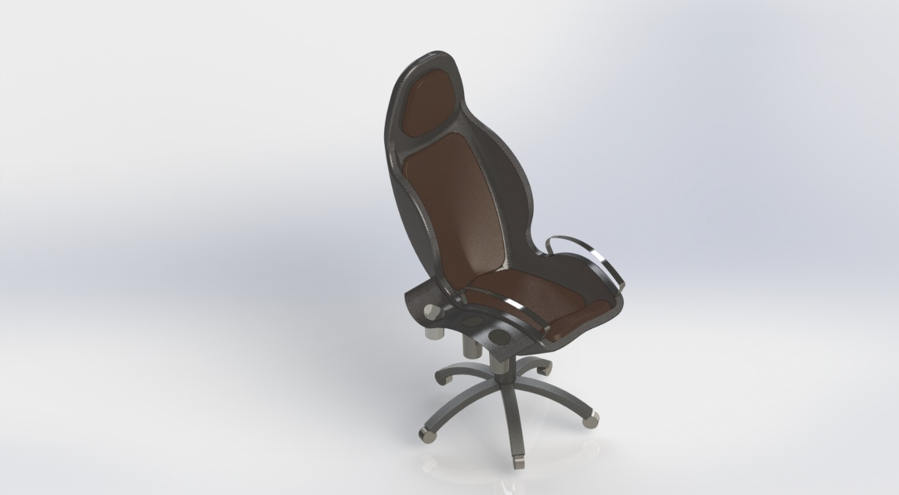

Our Design

The main objective kept in mind while designing this chair, has been to provide a perfect combination of comfort and convenience, while keeping it as minimalistic as possible.

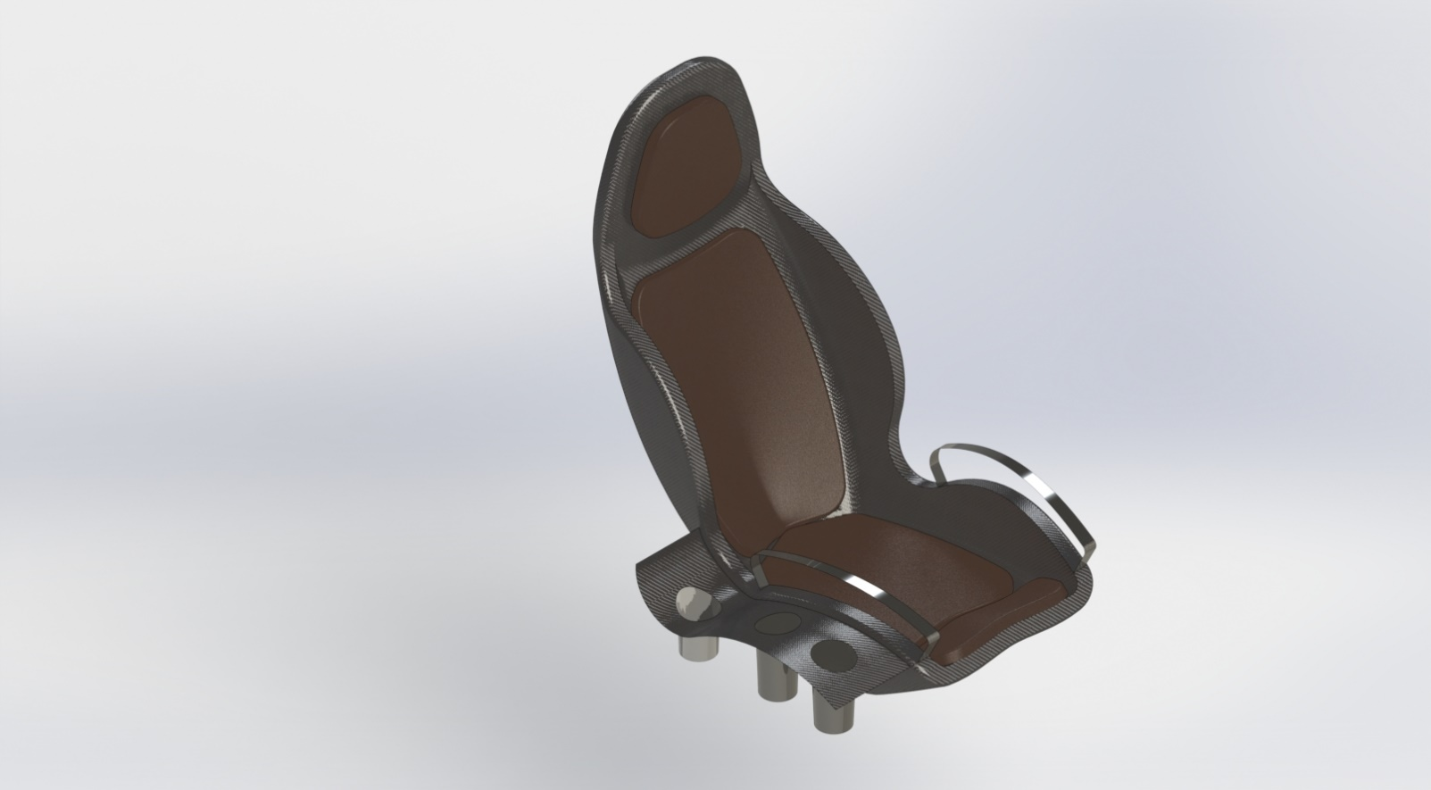The features:

1. Perforated cushioning and ventilation across the seat give a huge relief while working during hot summer afternoons.
2. Cup and stationary holders on our utility arm-rest, provide convenience for beverages and office supplies anytime.

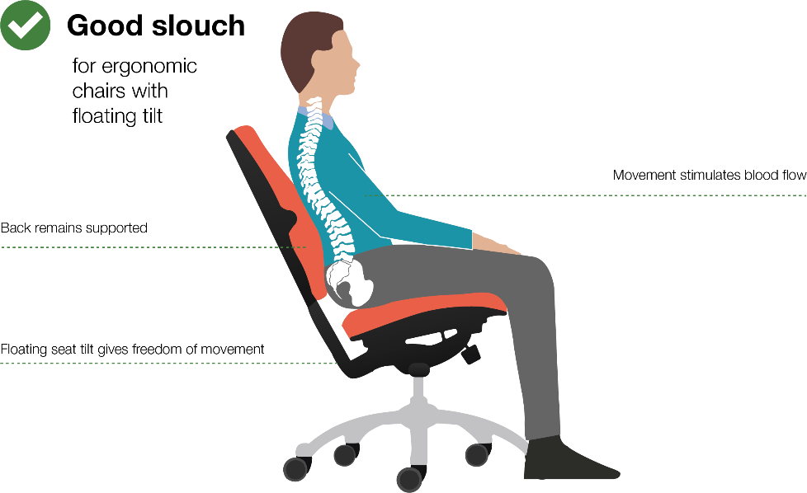

1. The carefully crafted design of the seat is made specifically to support a good posture. This posture not only keeps the spine straight, but also increases concentration.
2. Adjustable height and recline make this seat comfortable for people of all heights and posture preferences.

CAD Model

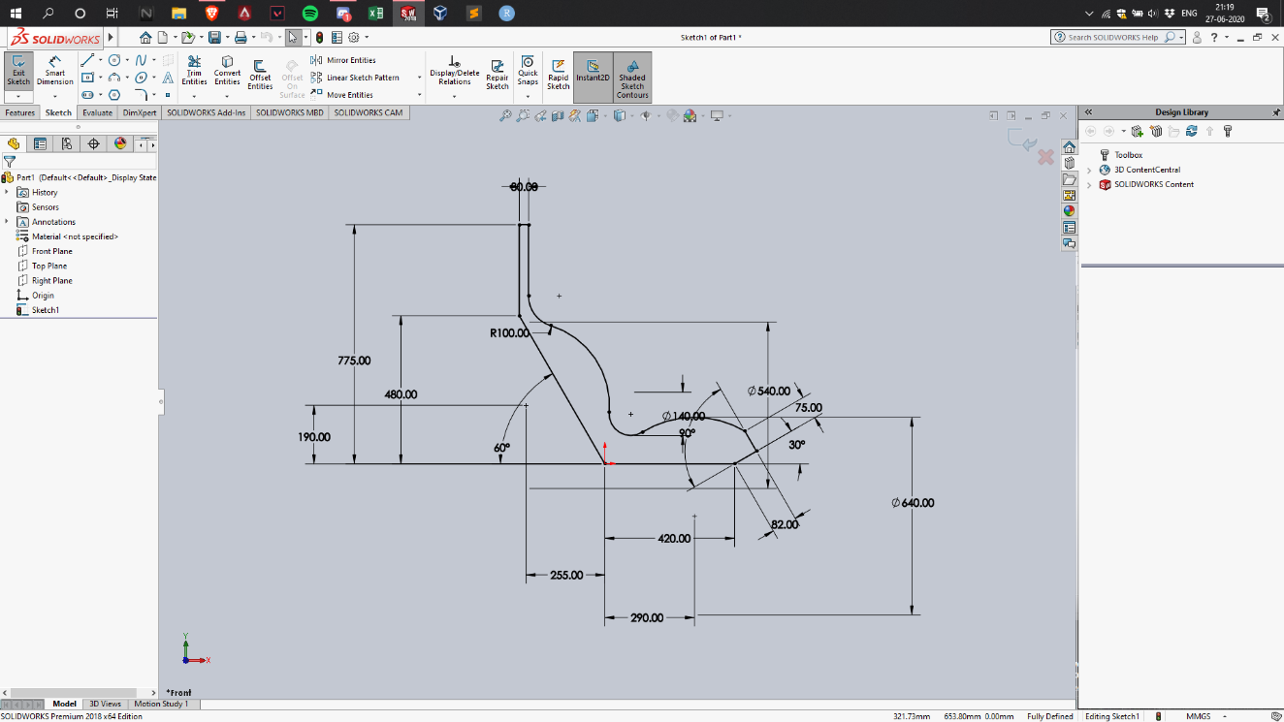

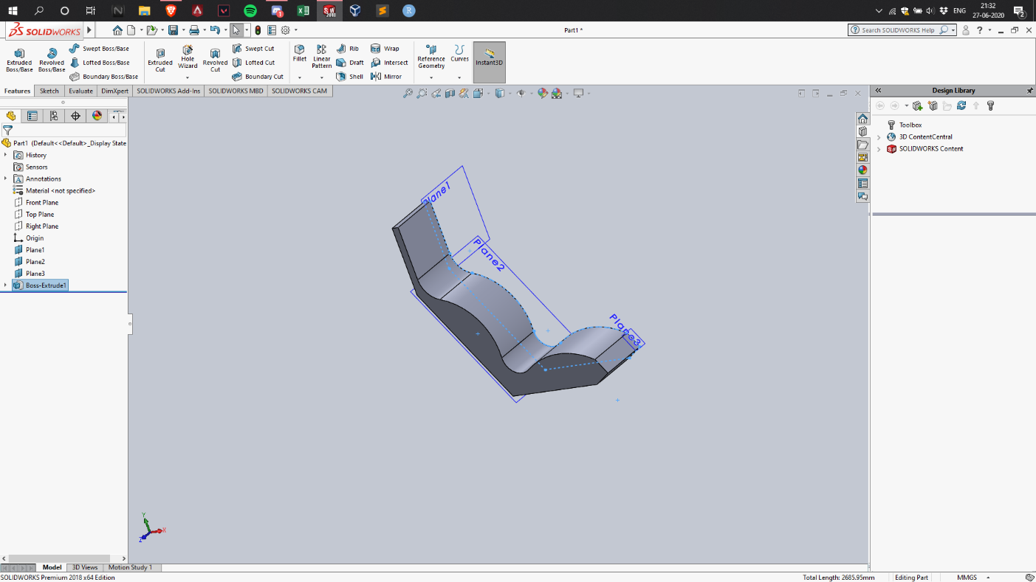

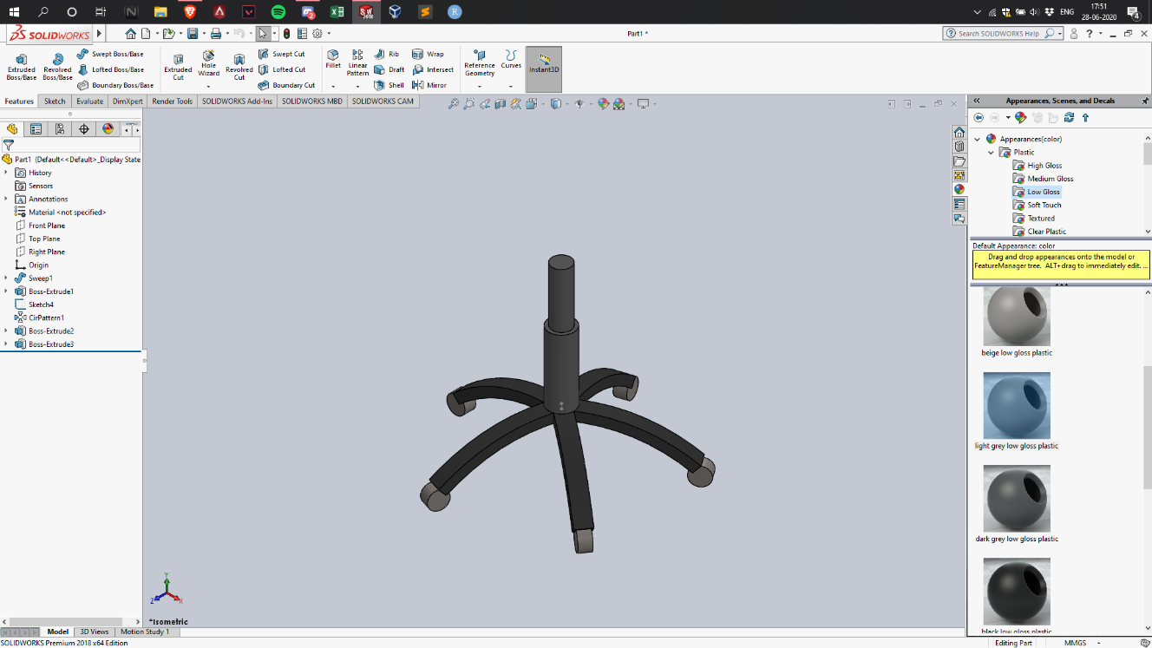

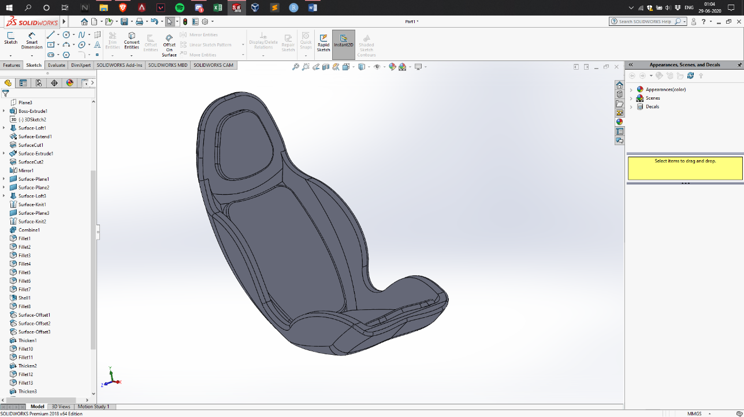

Steps

We started of simple by making the wheel base and sketching the seat. The seat being the trickiest component, made use of a variety of features. We used, Revolve Boss/Base, Surface Loft, Sweep, Surface Extends, Surface Offsets, Surface Cuts, Knits, Thicken, and Filleting amongst others. Finally, we rendered the final assembly with appropriate textures using PhotoView 360.

Final Renderings

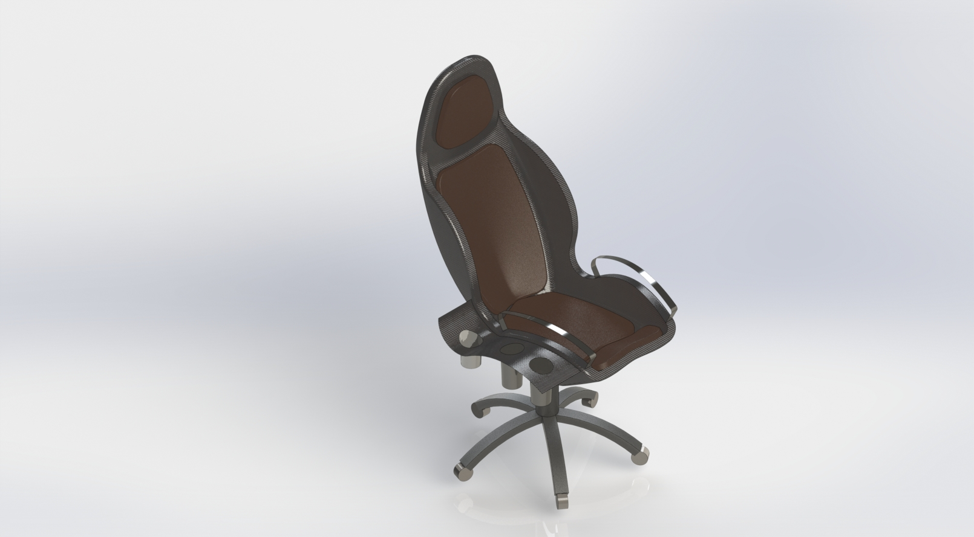

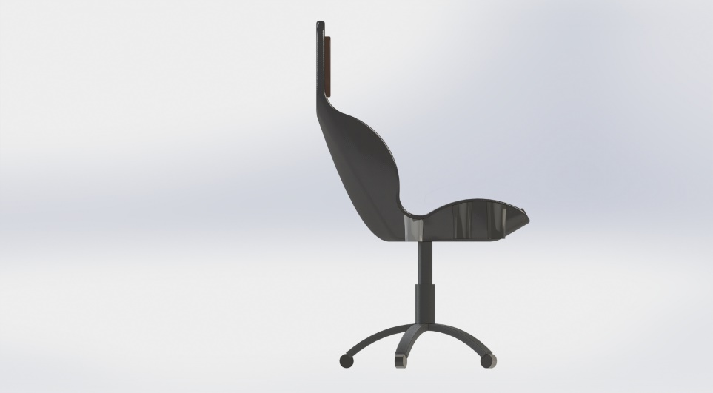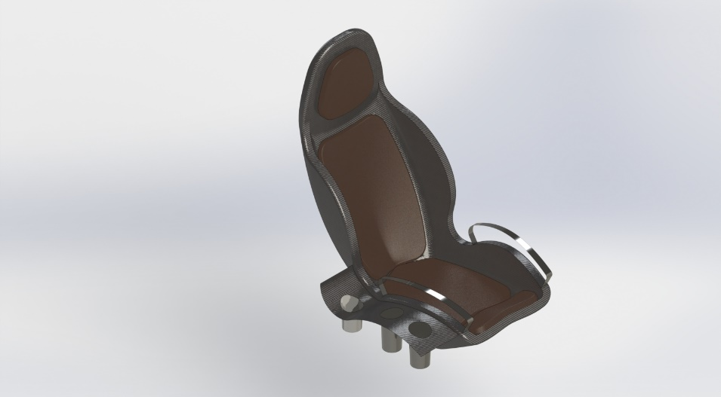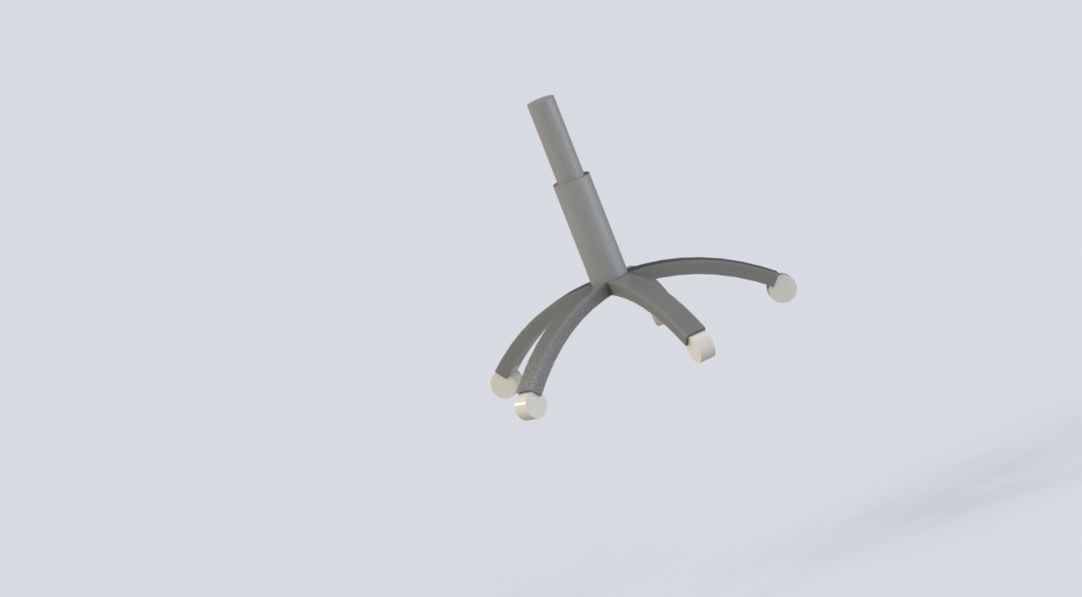

Link to the CAD Files: <https://grabcad.com/library/multi-utility-chair-1>